Tracking Tools Templates
Send this email after the KT. Ask the pm and the FC when is the KT with the client.
Will I do this in February or not? So I can update my forecast. En que semana y cuanto tiempo?
New Site – Customer has GA and GTM on their main site
Hi team, hope you’re doing great!
I'm Ilan from the Digital Experience team, and I will be assisting you during the transition to SuiteCommerce. As part of this transition, we need to install tracking tools in your new site, so I would like to request access to Google Analytics and Google Tag Manager for my email ilan.daniele@oracle.com
- Google Analytics 4: Administrator rights to create a new property.
- Google Tag Manager: Admin (account) and Publish (container) rights.

Let me know if you have any questions.
Thank you

New Site – Customer doesn’t has GA but has GTM on their main site
Hi XXX, hope you’re doing great!
I'm Ilan from the Digital Experience team, and I will be assisting you during the transition to SuiteCommerce. As part of this transition, we need to install tracking tools in your new site, so I would like to request access to Google Analytics and Google Tag Manager for my email ilan.daniele@oracle.com
- As you don’t have Google Analytics, please follow the steps below:
  - Set Up GA Account and Website Property
  - For GA4, from this guide instead of filling up Google Analytics Universal, you fill up the following (without activating Google Universal Analytics):
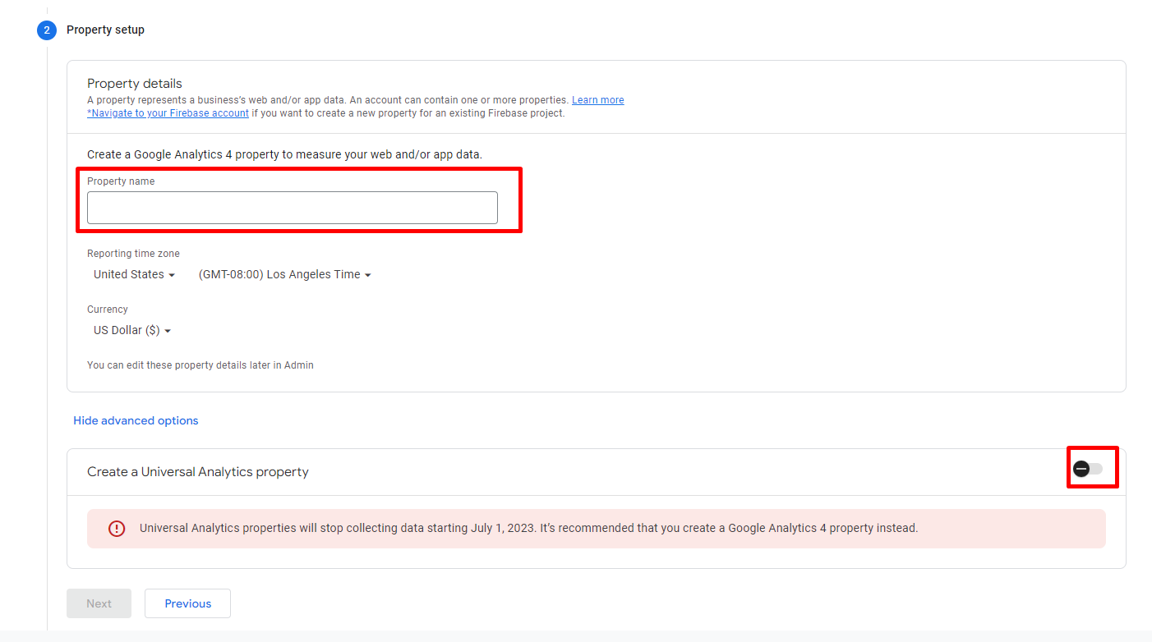
  - Follow steps from 1 to 12 under "To Set Up Your GA Account"
    - When creating the property please select the following options:
      - Select “Show advanced options”
      - Enable “Create a Universal Analytics property”
      - On “Website URL” select “https” and write the name of your domain
      - Select the option called “Create a Universal Analytics property only”
      - And then click "Next"
  - Provide ilan.daniele@oracle.com with “edit” rights at “property” level
- Google Tag Manager: I would need Admin permissions (account) and Publish (container) rights.

Let me know if you have any questions.
Thank you

New Site – Customer has GA but doesn’t has GTM on their main site
Hi XXX, hope you’re doing great!
I'm Ilan from the Digital Experience team, and I will be assisting you during the transition to SuiteCommerce. As part of this transition, we need to install tracking tools in your new site, so I would like to request access to Google Analytics and Google Tag Manager for my email ilan.daniele@oracle.com
Google Analytics: Admin rights to create a new property.
And as you don't have a Google Tag Manager account, please follow the steps below:

- Google Tag Manager:
  - Sign Up for Google Tag Manager
  - Follow steps from 1 to 11 under "To Sign Up for a GTM Account"
  - Provide ilan.daniele@oracle.com with "administrator" (account) and "publish" (container) rights
Let me know if you have any questions.
Thank you

New Site – Customer doesn’t have GA and GTM. (Password Protected)

Hi XXX,
I'm Ilan from the Digital Experience team, and I will be assisting you during the transition to SuiteCommerce. As part of this transition, our recommendation is to install tracking tools in your new site, so I would like to request access to Google Analytics and Google Tag Manager for my email ilan.daniele@oracle.com
As you don’t have tracking accounts, please follow the steps provided below:
- Google Analytics:
  - Set Up GA Account and Website Property
  - Follow steps from 1 to 12 under "To Set Up Your GTA Account"
    - When creating the property please select the following options:
      - Select “Show advanced options”
      - Enable “Create a Universal Analytics property”
      - On “Website URL” select “https” and write the name of your domain
      - Select the option called “Create a Universal Analytics property only”
      - And then click “Next”
  - Provide ilan.daniele@oracle.com with “edit” rights at “property” level
- Google Tag Manager:
  - Sign Up for Google Tag Manager
  - Follow steps from 1 to 11 under "To Sign Up for a GTM Account"
  - Provide ilan.daniele@oracle.com with “admin” and “publish” rights
Let me know if you have any questions.
Thank you

Migration – Customer has GA and GTM.

Hi XXX,

I'm Ilan from the Digital Experience team, and I will be assisting you during the transition to SuiteCommerce. First, we want to analyze your existing SEO traffic, to plan a migration path to mitigate any impact on Traffic/Rankings/Revenue from an SEO perspective.

For us to complete the analysis, I would like to request access to Google Analytics and Google Tag Manager for my email ilan.daniele@oracle.com

- Google Analytics: Edit rights. Property XXX

- Google Tag Manager: Admin (account) and Publish (container) rights.

We'll send you the results and the action items as soon as the analysis is complete.
Let me know if you have any questions.
Thank you

Migration – Customer has GA but no GTM.

Hi XXX,

I'm Ilan from the Digital Experience team, and I will be assisting you during the transition to SuiteCommerce. First, we want to analyze your existing SEO traffic, to plan a migration path to mitigate any impact on Traffic/Rankings/Revenue from an SEO perspective.

For us to complete the analysis, I would like to request access to Google Analytics and Google Tag Manager for my email ilan.daniele@oracle.com

- Google Analytics: Edit rights. Property UA-XXX.

And as you don't have a Google Tag Manager account, please follow the steps below:

- Google Tag Manager:
  - Sign Up for Google Tag Manager
  - Follow steps from 1 to 11 under "To Sign Up for a GTM Account"
  - Provide ilan.daniele@oracle.com with "administrator" (account) and "publish" (container) rights
We'll send you the results and the action items as soon as the analysis is complete.
Let me know if you have any questions.
Thank you

Migration – Customer doesn’t have GA and GTM.

Hi XXX,

I'm Ilan from the Digital Experience team, and I will be assisting you during the transition to SuiteCommerce. First, we want to analyze your existing SEO traffic, to plan a migration path to mitigate any impact on Traffic/Rankings/Revenue from an SEO perspective.

For us to complete the analysis, I would like to request access to Google Analytics and Google Tag Manager for my email ilan.daniele@oracle.com

As you don’t have tracking accounts, please follow the steps provided below:
- Google Analytics:
  - Set Up GA Account and Website Property
  - Follow steps from 1 to 12 under "To Set Up Your GTA Account"
    - When creating the property please select the following options:
      - Select “Show advanced options”
      - Enable “Create a Universal Analytics property”
      - On “Website URL” select “https” and write the name of your domain
      - Select the option called “Create a Universal Analytics property only”
      - And then click “Next”
  - Provide ilan.daniele@oracle.com with “edit” rights at “property” level
- Google Tag Manager:
  - Sign Up for Google Tag Manager
  - Follow steps from 1 to 11 under "To Sign Up for a GTM Account"
  - Provide ilan.daniele@oracle.com with “admin” and “publish” rights
We´ll send you the results and the action items as soon as the analysis is complete.

Let me know if you have any questions.
Thank you.

To provide me with access on GA3:
First, go to Google Analytics.
Open your GA3 property -> press on the left bottom wheel (Admin)
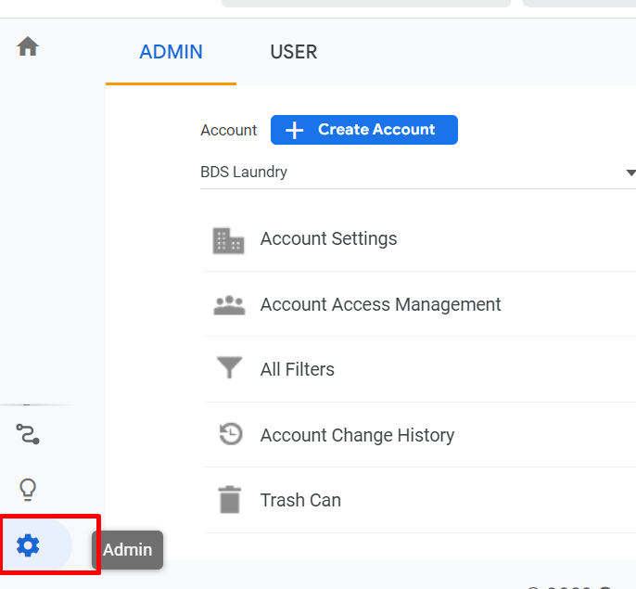
Then press on Account Access Management:
Press on add button on top right -> add Users:
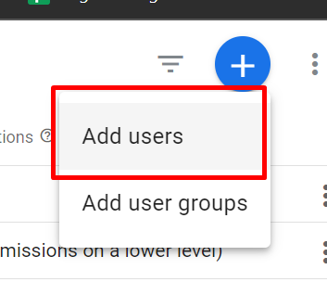
Then type down my email and set “administrator”:
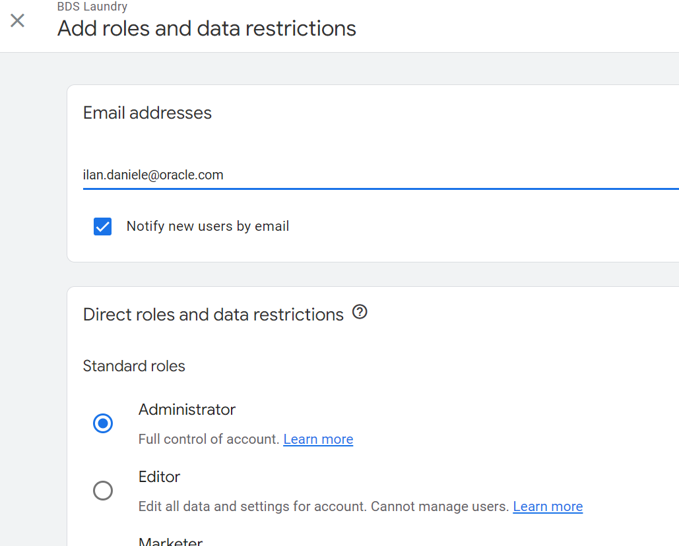

To provide me access on GA4:
On GA4, go to Admin on bottom left:
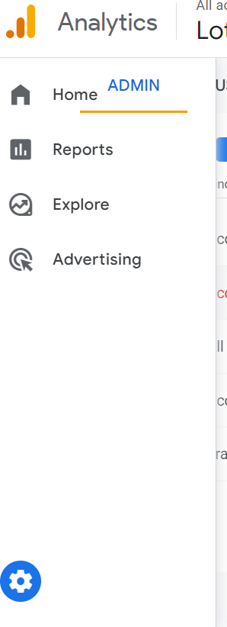
Then press: “Account Access Management”
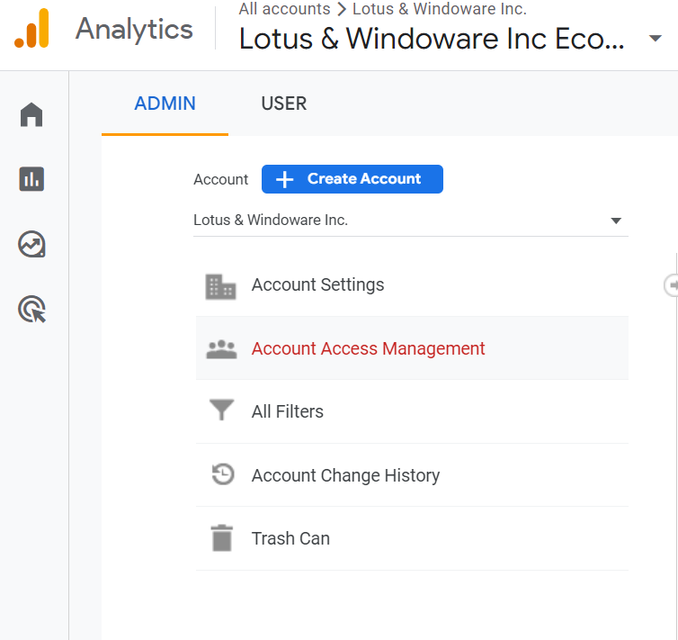
Then, top right, press on “+” -> Add “users”:
Then, set my email, and set permits as administrator:
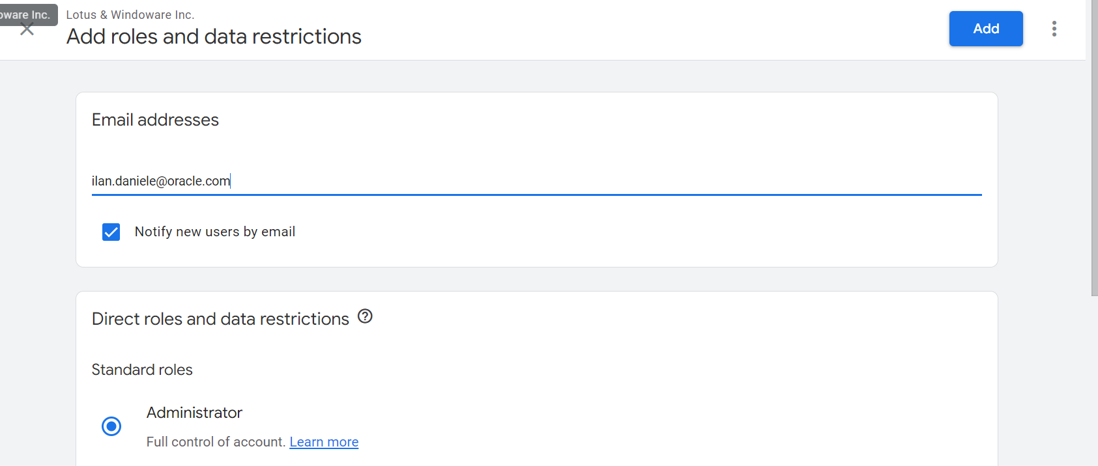

To provide me access on GTM:
Go to your GTM property -> press on Admin:
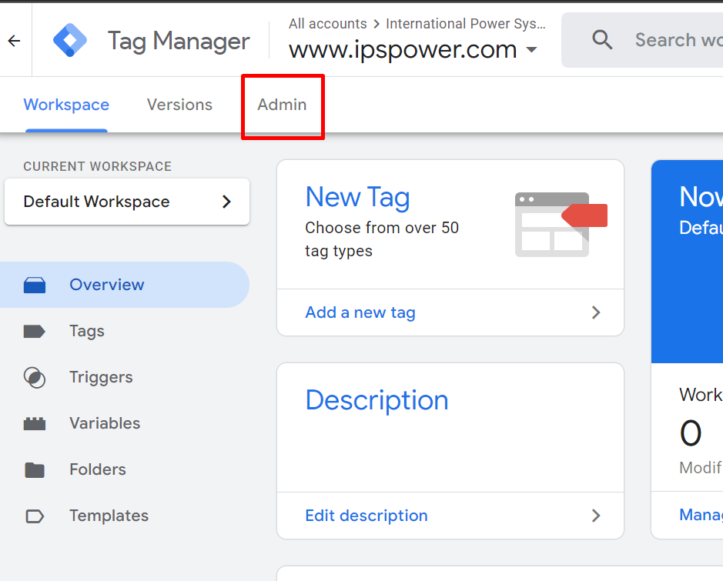
Then press on “User Management”:
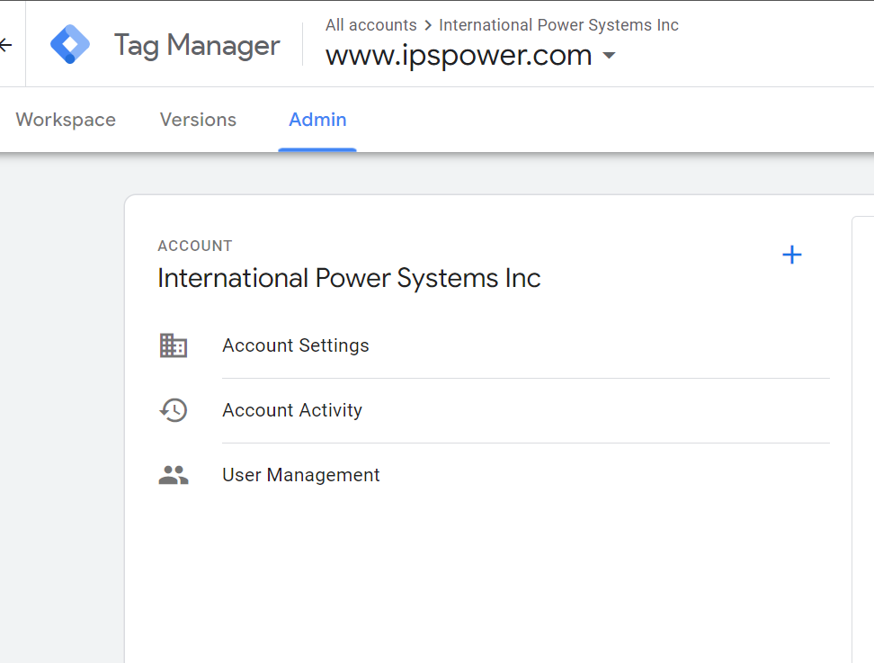
Then press on the top right “+” button:

Then, make sure you have Publisher and Administrator set:
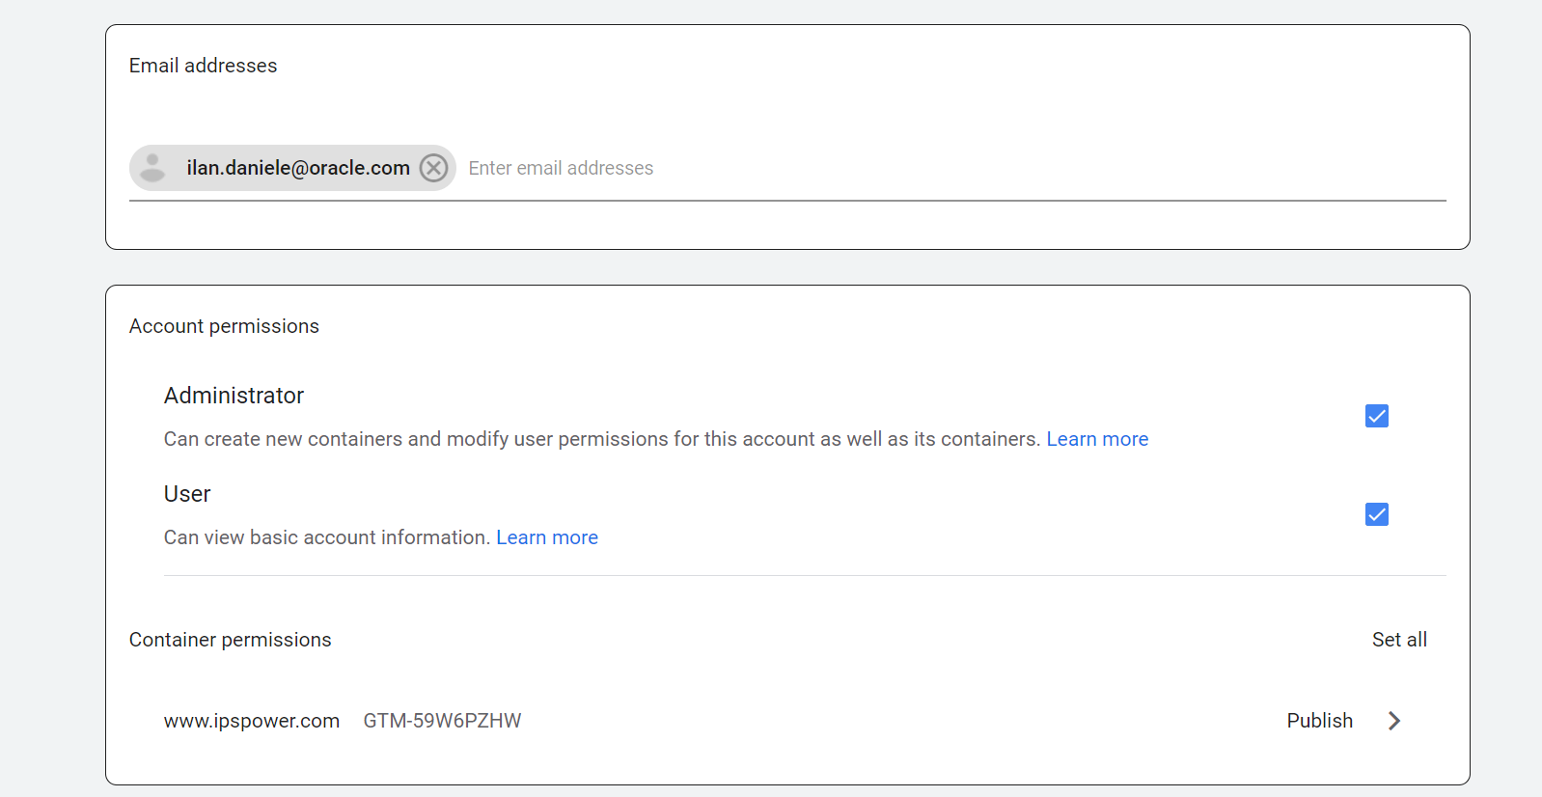
Then, make sure you press “invite”:

